1. **State 5 functional requirements and 5 non-functional requirements for an ATM machine. [pts. 10]**

Functional Requirements – Ability to check balance, ability to withdraw funds, ability to deposit a check, ability to transfer funds, ability to deposit cash

Non-functional Requirements – Total cost of installation, security against attacks, quickly return account information, system must be easy to use, ability to accept different types of credit cards­.

1. **UML: [pts: 4]**

**Draw a class model for “University” with the followings:**

* 1. **One private attribute: Name**
  2. **One private-static attribute: Instance**
  3. **Private default constructor:**
  4. **One public static method: get the instance in 1.ii above**
  5. **One public method: get the name in 1.i above**
  6. 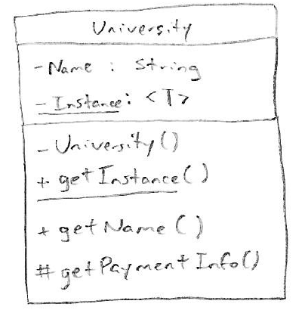**One protected method: anything**

1. **UML: [pts: 16]**

**Show the following UML Relationships with proper class model, relationship symbol, directionality, and multiplicity (for the classes just show the structure & name):**

1. **Composition between “StudentProfile” class and “Address” class**

**[pts. Class models 2x0.5+ relationship symbol: 1 + directionality: 1 + multiplicity: 1 = 4]**

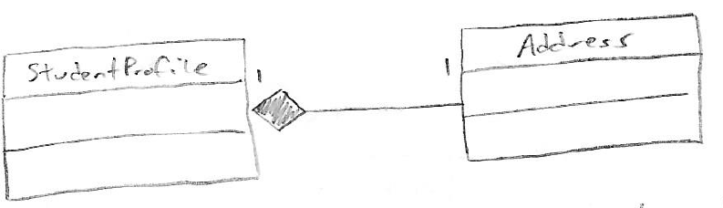

1. **Aggregation between “Student” class and “Course” class**

**[pts. Class models 2x0.5+ relationship symbol: 1 + directionality: 1 + multiplicity: 1 = 4]**

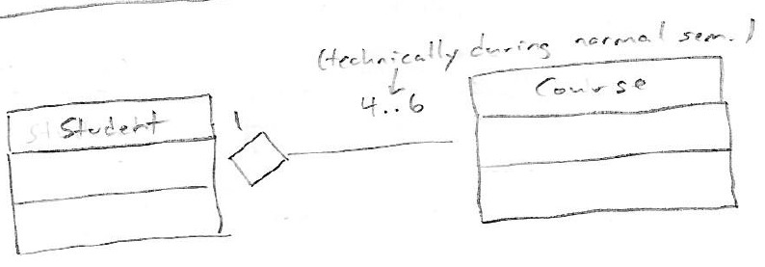

1. **Generalization between “People” and “Student”, “Faculty”, & “Staff” classes.**

**[pts. Class models 4x0.5+ relationship symbol: 1.5 + directionality: 1.5 = 5]**

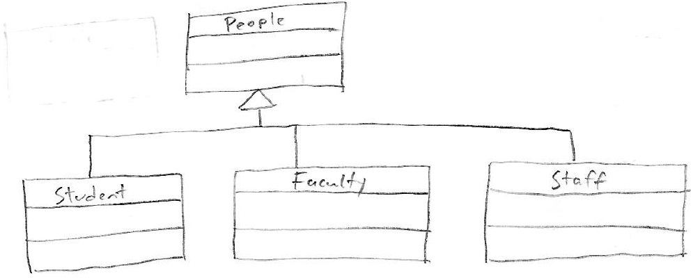

1. **Realization relationship between “MultimediaPlayerInt” interface and “MultiMediPlayer” class, where the latter is constructed from the former.**

**[pts. Class models 2x0.5+ relationship symbol: 1 + directionality: 1 = 3]**

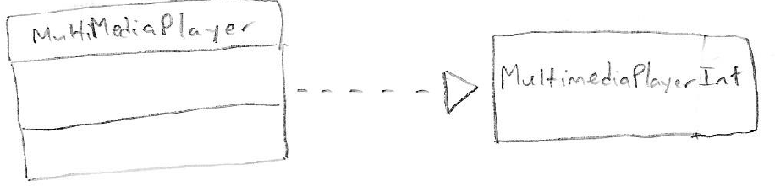

1. **UML – Use Case Diagram: [pts: 10]**

**For an e-commerce site draw a Use Case diagrams with 5 identified use cases and one actor.**

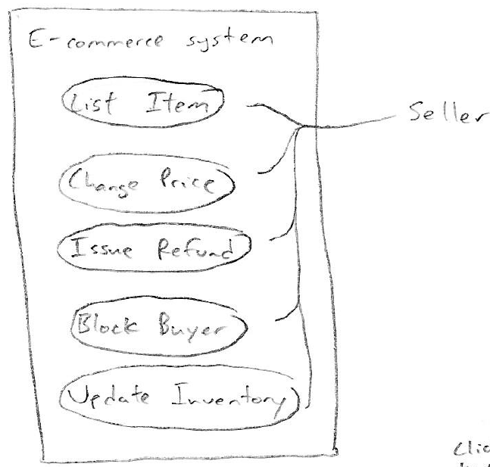

1. **UML – Activity Diagram: [pts: 10]**

**For a bill payment sub-system draw a simple activity diagram showing the following bill payment method options:**

1. **Credit Card (consider both success and failure scenarios)**
2. **Cash**

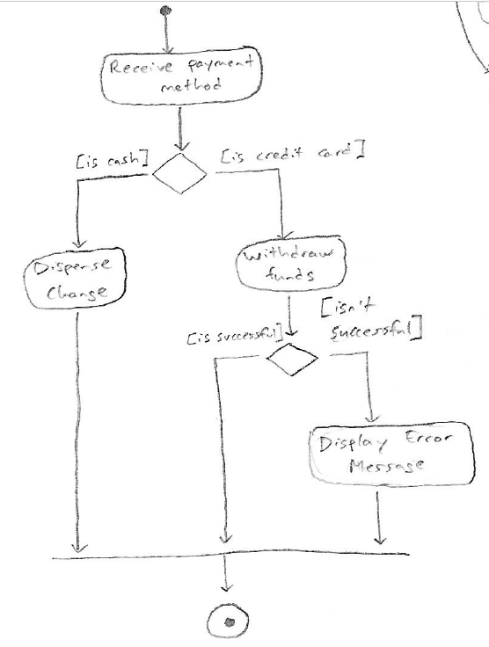

1. **UML – State Diagram: [pts: 10]**

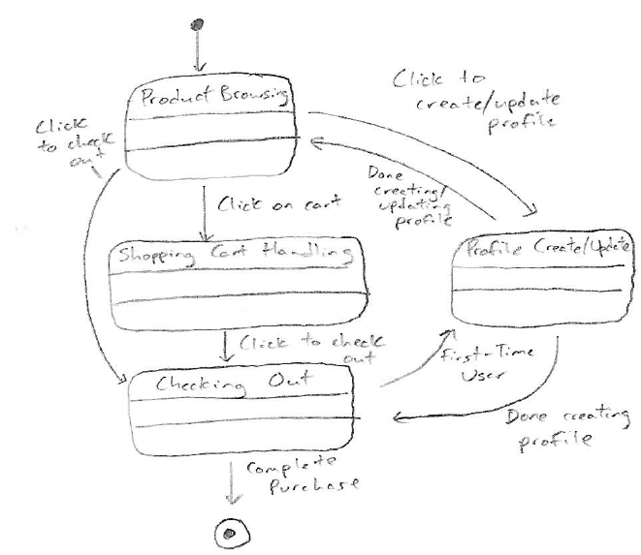**Draw a Simple State Diagram of an ecommerce system with the following states: Product browsing, Shopping Cart Handling, Checking Out, and Profile Create/Update.**